Name: _____________________ Class:__________ Date:__________
Instructions: Write answers in the right-hand column. Score: ___________ / 63 marks

Section A— Multiple choice (10 marks)

 | Which product in the following chemical reaction is dissolved in solution?  CaCO₃(s) + 2HCl(aq) → CaCl₂(aq) + CO₂(g) + H₂O(l)  A HCl  B CaCl₂  C CO₂  D H₂O | B | 1
 | Which unbalanced formula equation best represents the following word equation?  iron(III) oxide + carbon monoxide → iron + carbon dioxide  A Fe₂O₃ + CO → Fe + CO₂  B FeO + CO → Fe + CO₂  C Fe₂O₃ + CO₂ → Fe + CO  D FeO + CO₂ → Fe + CO | A | 1
 | Which of the following equations is balanced?  A C₂H₆ + O₂ → CO₂ + H₂O  B C₂H₆ + O₂ → 2CO₂ + 3H₂O  C C₂H₆ + 7O₂ → 2CO₂ + 3H₂O  D 2C₂H₆ + 7O₂ → 4CO₂ + 6H₂O | D | 1
 | Which of the following chemical reactions is a combination reaction?  A 2H₂O(l) → 2H₂(g) + O₂(g)  B 2H₂(g) + O₂(g) → 2H₂O(l)  C H₂O₂ → H₂ + O₂(g)  D H₂O + Na → NaOH + H₂ | B | 1
 | Which is the best term to describe the following reaction?  CaCO₃(s) → CaO(s) + CO₂(g)  - combination reaction  - metal displacement reaction  - precipitation reaction  - decomposition reaction | D | 1
 | When solutions of sodium chloride (NaCl) and silver nitrate (AgNO₃) are mixed, solid silver chloride (AgCl) forms. Which ions remain dissolved in the solution?  A Na⁺ and Cl⁻  B Ag⁺ and Cl⁻  C Na⁺ and 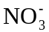  D Ag⁺ and | C | 1
 | Define the process of reduction.  A Reduction is the loss of oxygen or the gain of electrons.  B Reduction is the gain of oxygen or the loss of electrons.  C Reduction is the gain of oxygen or electrons.  D Reduction is the loss of oxygen or electrons. | A | 1
 | What is the main reason limestone is added to a blast furnace?  A to produce the carbon monoxide that reduces the iron or to iron metal  B to react with the carbon in the coke to produce carbon dioxide  C to reduce the iron ore to iron metal  D to react with the silicates in the ore and produce the slag that can be separated from the molten iron | D | 1
 | Explain why crushing solid reactants helps to increase the rate of reaction.  A It exposes more of the solid reactant to the other reactants so there can be more reactions occurring at any one time.  B It weakens the chemical bonds in the solid so that it is easier for the reaction to occur.  C It helps the solid to dissolve.  D All answers are correct. | A | 1
 | Explain why adding a catalyst to a reaction increases the rate of reaction.  A The catalyst can provide a pathway for the chemical reaction that requires less energy.  B The catalyst can help the reactant molecules to come together and react.  C The catalyst can force reactants into the correct arrangement so that they react.  D All answers are correct. | D | 1

Section B—Short answer (43 marks)

 | An experiment was conducted as shown in the diagram below.  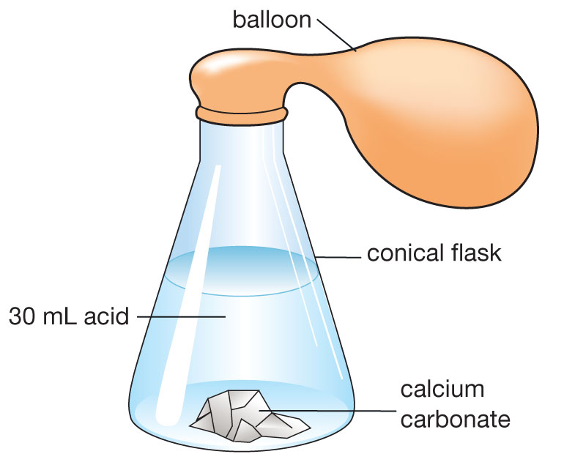  CaCO₃(s) was added to HCl(aq). The flask, contents and balloon were weighed before and after the reaction. The products of the reaction are water (H₂O), carbon dioxide gas (CO₂) and a solution of calcium chloride (CaCl₂).  - Write a balanced equation (including states) for the reaction occurring in the flask.  - Would you expect the mass after the reaction to be greater than, less than or equal to the mass before reaction? Justify your choice. | - CaCO₃(s) + 2HCl(aq) → CaCl₂(aq) + CO₂(g) + H₂O  - The mass should be the same before and after the reaction. The Law of Conservation of Mass states that mass is neither created nor destroyed during a chemical reaction.  or  The mass would be slightly less because some gas might have been lost when the balloon was being attached to the flask, as the reaction was beginning. | 5
 | Determine the balanced formula equation, including states, for each of the reactions described below:  - _P₄ + _O₂ → _P₂O₅(s)  - _KClO₃(s) → _KCl(s) + _O₂(g) | - P₄ + 5O₂ → 2P₂O₅(s)  - 2KClO₃(s) → 2KCl(s) + 3O₂(g) | 6
 | Write a balanced formula equation, including states, for each of the reactions described below.  - When aqueous solutions of lead(II) nitrate, Pb(NO₃)₂, and potassium iodide, KI, are mixed, the yellow solid lead(II) iodide, PbI₂, precipitates from the solution, while the soluble salt, potassium nitrate, KNO₃, remains in solution.  - An aqueous solution of ethanol, C₂H₅OH, is produced when a glucose, C₆H₁₂O₆, solution reacts in the presence of a yeast catalyst. Gaseous carbon dioxide, CO₂, is also produced. | - Pb(NO₃)₂(aq) + 2KI(aq) → PbI₂(s) + 2KNO₃(aq)  - C₆H₁₂O₆(aq) → 2C₂H₅OH(aq) + 2CO₂(g) | 8
 | Use any of the terms in the list below to identify each of the reactions shown.  decomposition, precipitation, metal displacement, combustion, combination  a Pb(NO₃)₂(aq) + 2KCl(aq) → PbCl₂(s) + 2KNO₃(aq)  b C₆H₁₂O₆(aq) + 6O₂(g) → 6CO₂(g) + 6H₂O(1)  c Mg(s) + ZnCl₂(aq) → MgCl₂(aq) + Zn(s) | a precipitation  b redox, oxidation or combustion  c redox or metal displacement | 3
 | The table below shows the symbol or formula of several ions.  Construct the chemical formula for:  a magnesium nitride  b ammonium hydroxide  c magnesium hydroxide. | a Mg₃N₂  b NH₄OH  c Mg(OH)₂ | 4
  Name of ion | Symbol or formula
  ammonium | NH
  magnesium | Mg²⁺
  calcium | Ca²⁺
  aluminium | Al³⁺
  carbonate | CO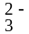
  hydroxide | OH–
  nitride | N^{3–}
 | Use the information from question 5 to name these chemicals.  a Al₂(SO₄)₃  b MgCO₃  c Ca(OH)₂ | a aluminium sulfate  b magnesium carbonate  c calcium hydroxide | 3
 | The table below shows the solubility of several ions.  Use this table to help you construct equations for the following reactions. You should include states (aq, s, g) in your equations.  a Solutions of sodium sulfate (Na₂SO₄) and barium chloride (BaCl₂) are mixed.  b Solutions of lead(II) nitrate (Pb(NO₃)₂) and potassium chloride (KCl) are mixed. | a Na₂SO₄(aq) + BaCl₂(aq) →  2NaCl(aq) + BaSO₄(s)  b Pb(NO₃)₂(aq) + 2KCl(aq) →  PbCl₂(s) + 2KNO₃(aq) | 4
  Negative ion | Positive ion | Solubility of compounds
  NO | all | soluble
  SO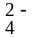 | Ba²⁺ Pb²⁺  others | insoluble  soluble
  Cl – | Ag⁺ Pb²⁺  others | insoluble  soluble
 | The production of iron metal from iron ore uses a complex series of reactions that all take place within a blast furnace. The reactions are:  A 2C + O₂ → 2CO  B Fe₂O₃ + CO → Fe + CO₂  C CaCO₃ → CaO + CO₂  D SiO₂ + 2CaO → Ca₂SiO₄  Identify which of these reactions are:  a combination reactions  b decomposition reactions  c combustion reactions | a reactions A and D  b reaction C only  c reactions A and B | 3
 | List five ways in which the rate of a reaction may be increased. | - higher temperature  - more concentrated reactants  - agitation (stirring)  - larger surface area  - use of a catalyst | 5
- E | Explain the two ways in which increasing the temperature can help to increase the rate of reaction. | 1 Increasing the temperature increases the speed of the reactant particles meaning that there are more collisions per second.  2 Increasing the temperature gives the reactant particles more energy so they the atoms are more likely to rearrange to form the products after a collision. | 2

Section C— Thinking scientifically (10 marks)

 | In a blast furnace, carbon (in the form of coke) reacts with oxygen to form carbon monoxide. The carbon monoxide then reduces the iron (III) oxide to form iron metal and carbon dioxide. This two-step process can be described by the formula equations:  2C(s) + O₂(g) → 2CO(g)  Fe₂O₃(s) + 3CO(g) → 2Fe(s) + 3CO₂(g)  If 1000 carbon atoms undergo this reaction, determine how many CO₂ molecules would be produced.  A 667  B 1000  C 1500  D 2000 | B | 1
 | Use the information from question 1 to determine how many iron atoms would be produced from 1000 carbon atoms.  A 667  B 1000  C 1500  D 2000 | A | 1
 | James burnt 25 g of calcium in air to produce calcium oxide according to the reaction:  2Ca(s) + O₂(g) → 2CaO(s)  After the reaction, James found that the mass of calcium oxide produced was 35 g. Given this information, calculate how many times heavier a calcium atom is compared to an oxygen atom.  A 2 times heavier  B 2.5 times heavier  C 3 times heavier  D cannot be calculated because oxygen is a gas so has no weight | B | 1
 | Kaleb was given an unknown solution and told that it could be one of four solutions – potassium nitrate, silver nitrate, calcium nitrate or iron (II) nitrate.  To identify the unknown, Kaleb combined the unknown solution with various known solutions to see whether or not a precipitate was formed. His results are summarised in the table below:  Use the solubility rules in the table below to deduce the compound in the unknown solution.  A potassium nitrate  B silver nitrate  C calcium nitrate  D iron(II) nitrate | D | 1
  Unknown combined with… | Precipitate (Yes/No)
  Sodium chloride (NaCl) | No
  Sodium carbonate (Na₂CO₃) | Yes
  Sodium sulfide (Na₂S) | Yes
  Negative ions (anions) | Positive ions (cations) | Solubility of Compounds
  All | Li⁺, Na⁺, K⁺, Rb⁺, NH₄⁺ | Soluble
  Chloride, Cl–  Iodide, I– | Ag⁺, Pb²⁺, Hg²⁺, Cu⁺ | Insoluble
  Chloride, Cl–  Iodide, I– | All others | Soluble
  Nitrate, NO₃⁻ | All | Soluble
  Carbonate, CO₃^{2–} | Li⁺, Na⁺, K⁺, Rb⁺, NH₄⁺ | Soluble
  Carbonate, CO₃^{2–} | All Others | Insoluble
  Sulfide, S^{2–} | Li⁺, Na⁺, K⁺, Rb⁺, NH₄⁺, Be²⁺, Mg²⁺, Ca²⁺, Sr²⁺, Ba²⁺ | Soluble
  Sulfide, S^{2–} | All others | Insoluble
 | Francesca came into the lab and found that the labels on her bottles of sodium nitrate, sodium sulfate and sodium iodide had fallen off. She decided to relabel the bottles X, Y and Z and then perform some tests by combining each solution with solutions of silver nitrate, lead nitrate, calcium nitrate and barium nitrate to see if there was a precipitation reaction. The results of her tests are summarised in the table below.  Use the solubility rules from question 4 to determine the contents of each bottle.  A X = sodium nitrate; Y = sodium sulfate; Z = sodium iodide  B X = sodium sulfate; Y = sodium iodide; Z = sodium nitrate  C X = sodium iodide; Y = sodium sulfate; Z = sodium nitrate  D X = sodium iodide; Y = sodium nitrate; Z = sodium sulfate | C | 1
   | Silver nitrate | Lead nitrate | Calcium nitrate | Barium nitrate
  X | Yes | Yes | No | No
  Y | No | No | Yes | Yes
  Z | No | No | No | No
 | Sandra has three unknown metals X, Y and Z. She wants to determine their order in the activity series so performs a series of metal displacement experiments. The table below summarises her results:  Given that metals higher on the activity series will only displace the ions of metals lower on the activity series, deduce the order of the metals on the activity series from highest to lowest.  A X, Y, Z  B X, Z, Y  C Z, Y, X  D Z, X, Y | D | 1
   |  | Ions formed in solution
   |  | X⁺ | Y⁺ | Z⁺
  Metals | X | - | Yes | No
  Metals | Y | - | - | No
  Metals | Z | Yes | Yes | -
 | Hydrogen peroxide decomposes spontaneously according to the reaction  H₂O₂(l) → H₂(g) + O₂(g)  The rate of decomposition is affected by both heat and light as shown by the graphs below.  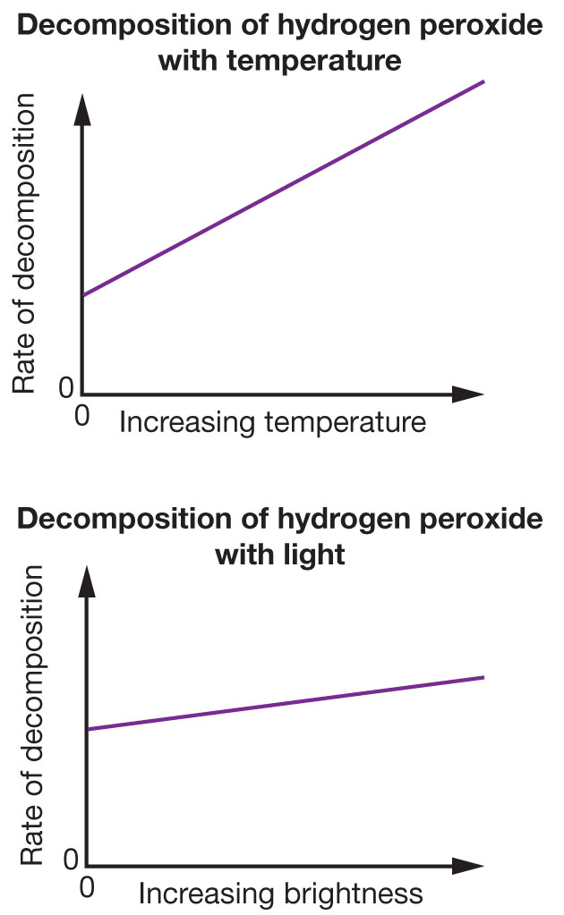  Use the graphs to determine the best method for storing hydrogen peroxide.  A A cool place in a black plastic bottle  B A cool place in a clear glass bottle  C A warm place in a black plastic bottle  D A warm place in a clear glass bottle | A | 1
 | Sam is experimenting with a new process of producing aspirin. He wants to optimise the process so that the reaction takes the shortest amount of time possible to produce the aspirin.  To do this Sam performs six different experiments to see how different factors affect the rate of reaction. Using identical amounts of all the reactants, Sam times how long it takes for the reaction to complete under different circumstances. His results are summarised in the graph below.  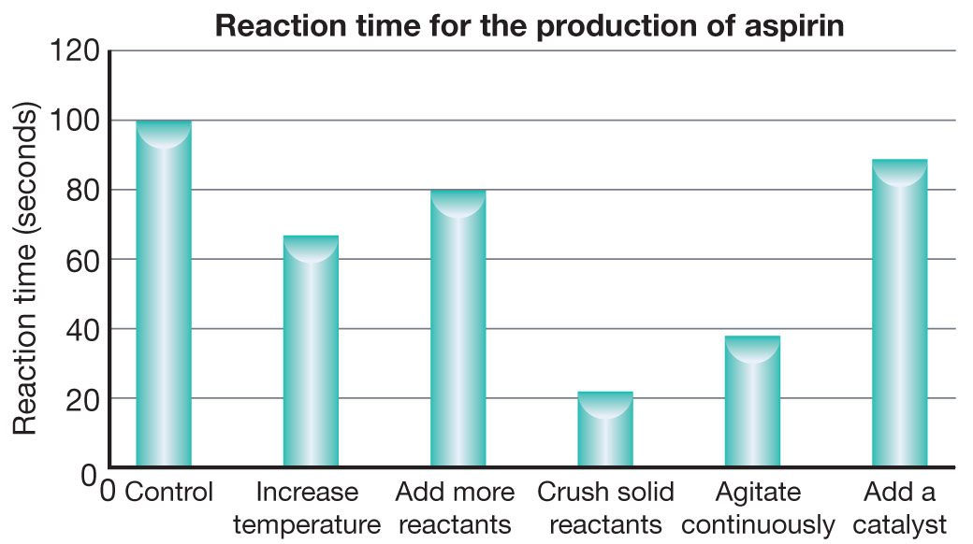  Use the graph to list the methods for optimising the reaction time from most effective to least effective.  A add a catalyst; add more reactants; increase temperature; agitate continuously; crush solid reactants  B increase temperature, add a catalyst; add more reactants; crush solid reactants; agitate continuously  C add a catalyst; increase temperature; crush solid reactants; add more reactants; agitate continuously  D crush solid reactants; agitate continuously; increase temperature; add more reactants; add a catalyst | D | 1
 | Sarah decided to see the effect of temperature on the reaction of magnesium metal with concentrated hydrochloric acid, which follows the chemical equation:  Mg(s) + 2HCl(aq) → MgCl₂(aq) + H₂(g)  To do this, she timed how long it took for all the magnesium metal to stop producing gas at different temperatures. She also ensured the size and shape of the magnesium metal was always kept constant as well as the concentration and volume of hydrochloric acid. Her results are summarised in the graph below:  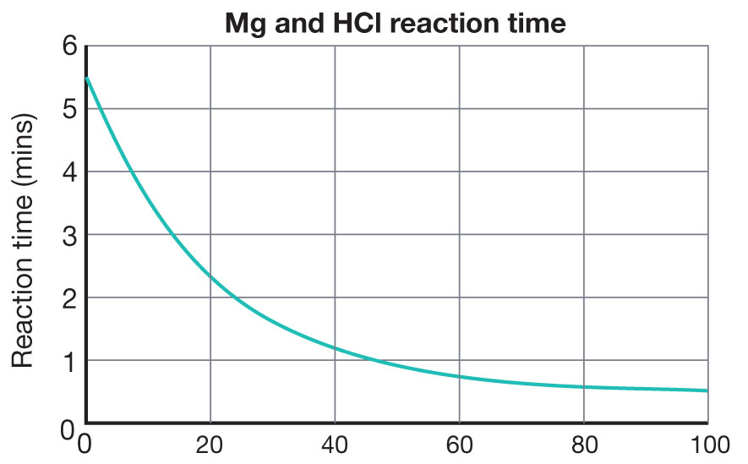  From this graph, deduce which of the following conclusions is most accurate.  A The time taken for the reaction to complete increases linearly as the temperature increases.  B The time taken for the reaction to complete decreases linearly as the temperature increases.  C Increasing the temperature initially reduces the reaction time a lot but only reduces the reaction time a small amount as the temperature gets higher.  D Increasing the temperature initially has little effect on the reaction time but rapidly reduces the reaction time as the temperature gets higher. | C | 1
 | Use the data from question 9 to determine the temperature at which the data in the graph below was taken.  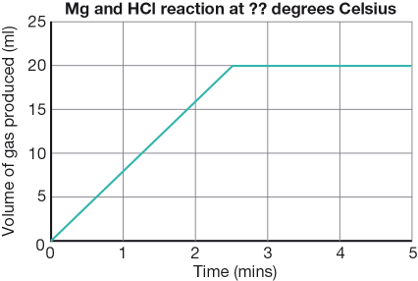  A 5°C  B 19°C  C 35°C  D 67°C | B | 1

